Name – Devansh Bamrara

Course - BCA   
  
Section – 5 B   
  
Roll No. – 1921053 / 18   
  
Subject Name - Web Development  
Subject Code - TBC 501

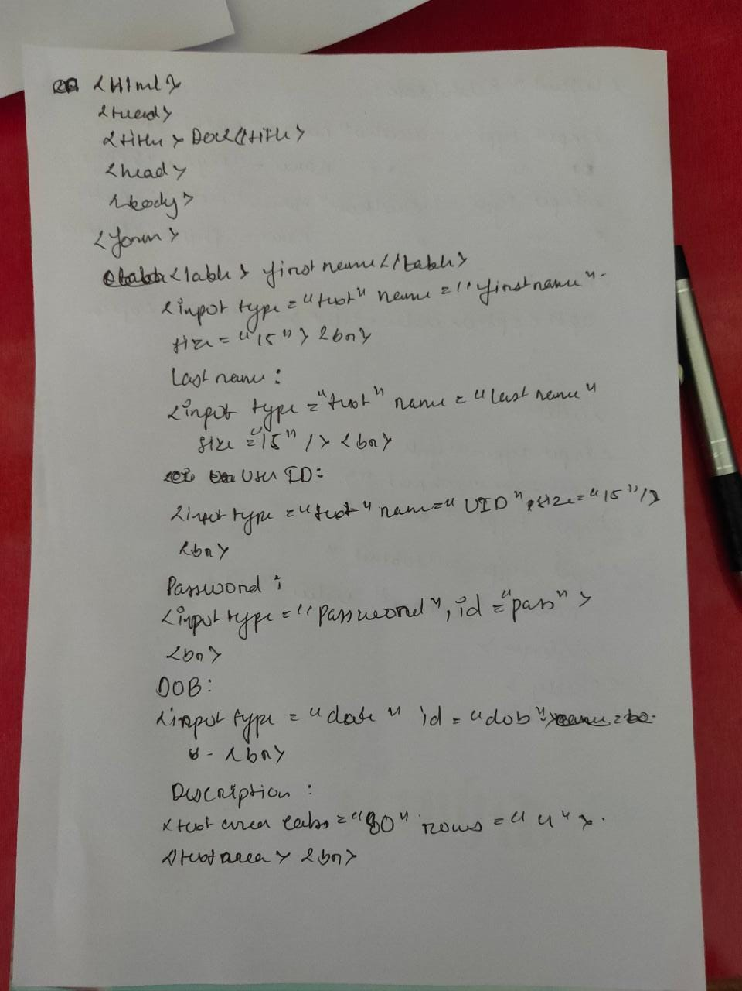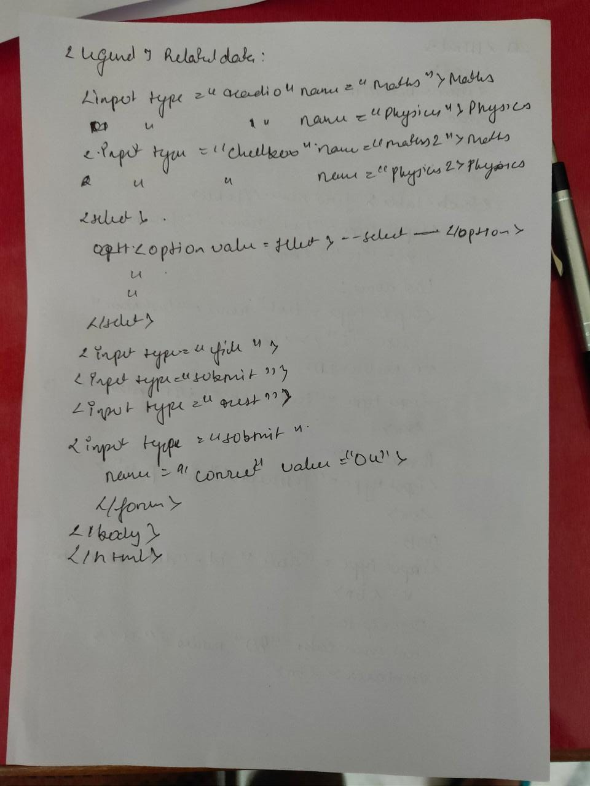

**Code**

<!DOCTYPE html>

<html lang="en">

<head>

    <meta charset="UTF-8">

    <meta http-equiv="X-UA-Compatible" content="IE=edge">

    <meta name="viewport" content="width=device-width, initial-scale=1.0">

    <title>Document</title>

</head>

<body>

    <form>

        <label> Firstname </label>

        <input type="text" name="firstname" size="15"/> <br> <br>

        <label> Lastname: </label>

        <input type="text" name="lastname" size="15"/> <br> <br>

        <label> UserID: </label>

        <input type="text" name="UID" size="15"/> <br> <br>

        <label> Password: </label>

        <input type="Password" id="pass" name="pass"> <br>

        <br> <br>

        <label> DOB: </label>

        <input type="date" id="dob" name="Dob"> <br>

        <br> <br>

        <label>Description : </label>

        <br>

        <textarea cols="80" rows="5" value="address">

        </textarea>

        <br> <br>

        <legend>Related Data:</legend><br>

            <input type="radio" name="Maths"/> Maths

            <input type="radio" name="Physics"/> Physics <br>

            <input type="checkbox" name="Maths2"/>Maths

            <input type="checkbox" name="Physics2"/>Physics <br><br>

            <select>

            <option value="Select">--Select--</option>

            <option value="Maths">Maths</option>

            <option value="Physics">Physics</option>

            </select>

        <input type="file" name="FILE"> <br><br><br>

        <input type="submit" name="Submit" value="Submit">

        <input type="reset" name="reset" value="Reset">

        <input type="submit" name="Correct" value="OK">

        </form>

</body>

</html>

**Output**

